**Falling Sands – Code Instructions & Documentation**

Alex Taradachuk, Cesar Mu, Isaac Segal, David Doktorman Mr. Platek pd. 8

1. **How to run the code**
   1. Run SandLab.java, which will open a new GUI called Falling Sand
      1. 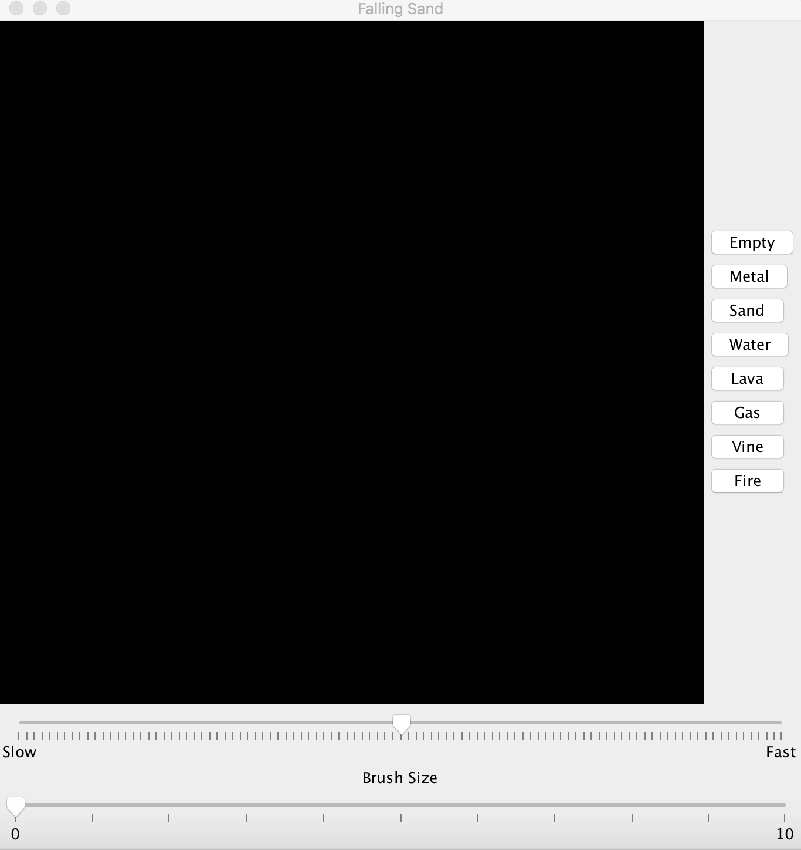
      2. **The Sandbox**: a 2 dimensional array, portions of it turn into different colors depending on the position of certain particles within the array
      3. **Brush Size**: determines the size of the portion of the screen that the particles are placed on
      4. **Speed**: determines how fast the particles fall
      5. **Empty**: default state (black)
      6. **Metal:**solid that prevents other particles from falling/rising up, can be melted slowly by lava (grey)
      7. **Sand**: sand particle, melts when it comes into contact with lava or fire (yellow)
      8. **Water**: water particle, turns into gas when it comes into contact with lava (blue)
      9. **Lava**: lava particle, acts similarly to fire, turns water to gas when it comes into contact with it, causes gas to set fire when it comes into contact with it, burns vines when it comes into contact with them (orange)
      10. **Gas**: gas particle, produced by mixing water and lava, catches fire when it comes into contact with lava or gas (light grey)
      11. **Vine**: similar properties as metal, except it grows downwards and sets fire when it comes into contact with lava or fire (green)
      12. **Fire**: similar properties as lava, except it doesn’t fall; rather, it only appears as long as the user is clicking on a location (orange)